USER INTERFACE FOR PRESIDIO
1. Introduction
This document provides step-by-step instructions to install, run, and use the AI-Powered PII Detection & Masking Tool built using Microsoft Presidio.
The tool supports multiple file formats and helps identify and protect sensitive data such as:
- Names
- Phone numbers
- Email addresses
- Credit card details
- IP addresses
- Locations
2. System Requirements
Ensure the following are available:
- Python 3.8 or above
- Internet connection (for initial setup)
- Minimum 4GB RAM recommended
3. Installation Steps
Step 1: Install Python
Download and install Python from: https://www.python.org/downloads/
Verify installation in cmd:
- Python –version
Step 2: Create Project Folder
Folder: Presidio-ui & Open the folder in VS Code
Step 3: Python Scripts
Create a file in Presidio-ui and name it as app.py

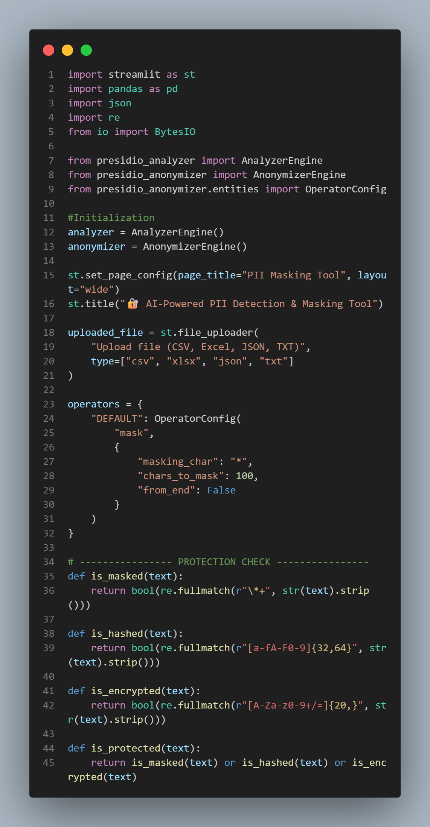
Step 4: Install the libraries & Initialize for Presidio
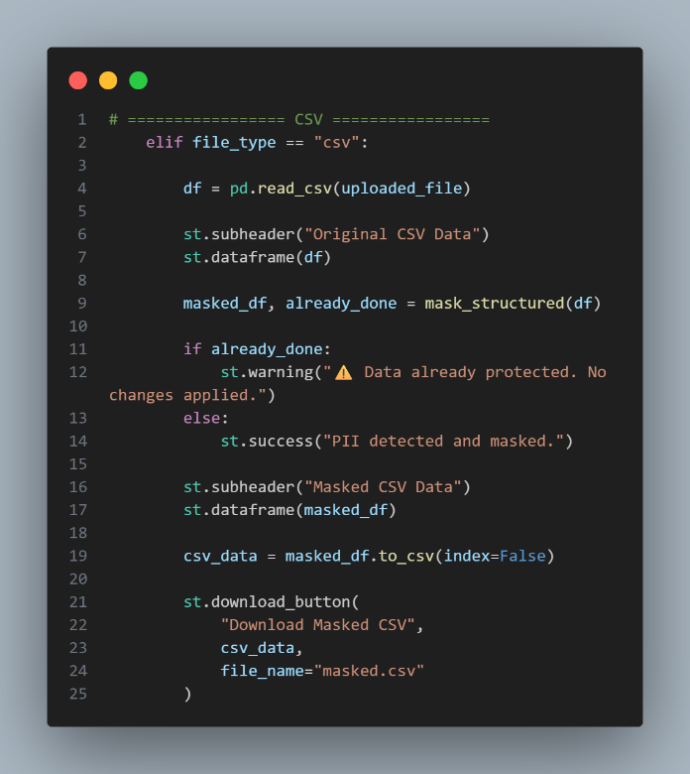
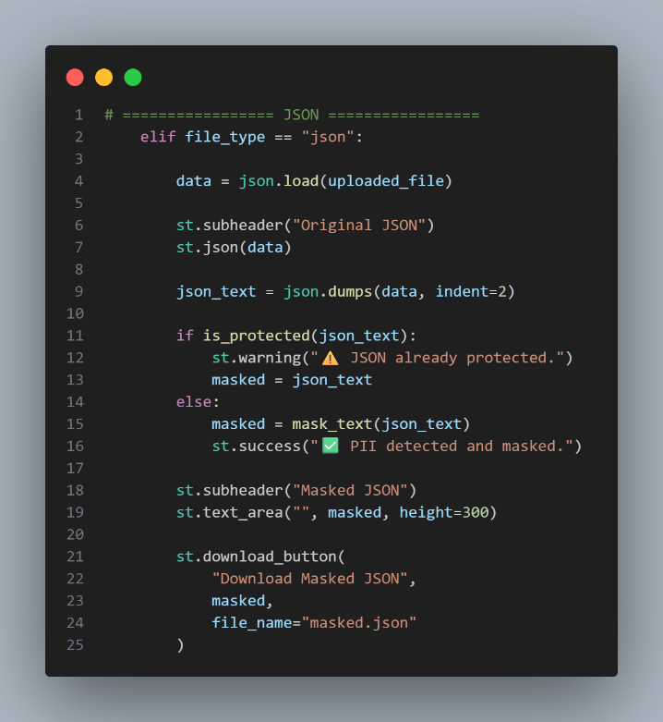
Step 5: Code for JSON,Txt,Csv,xls
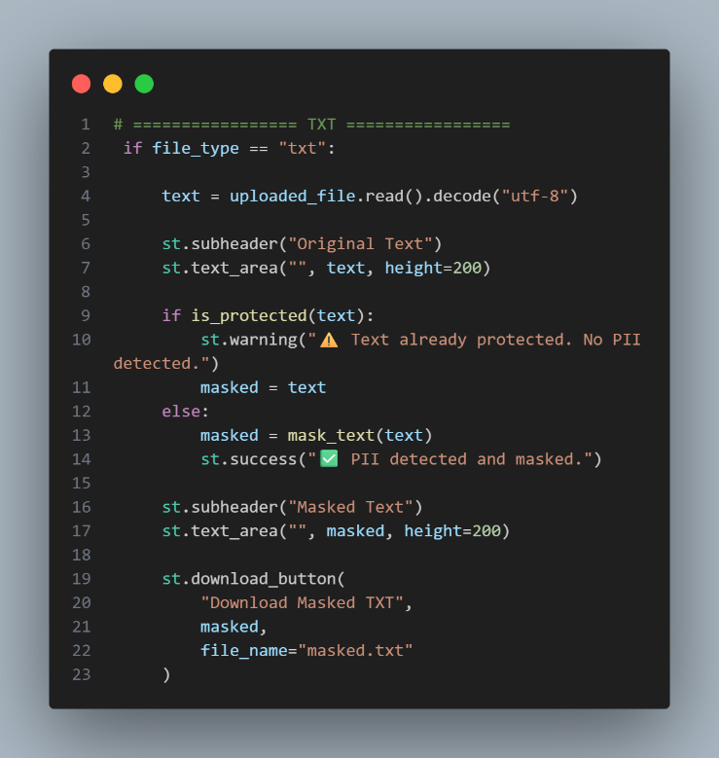
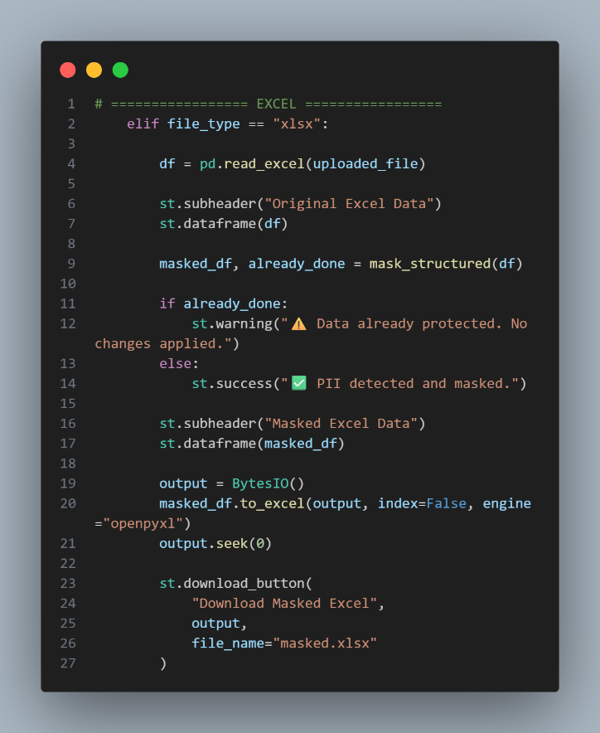

Step 6: Open Terminal in VS code & Run this cmd
>pip install streamlit presidio-analyzer presidio-anonymizer pandas openpyxl

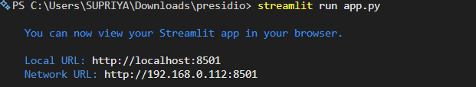
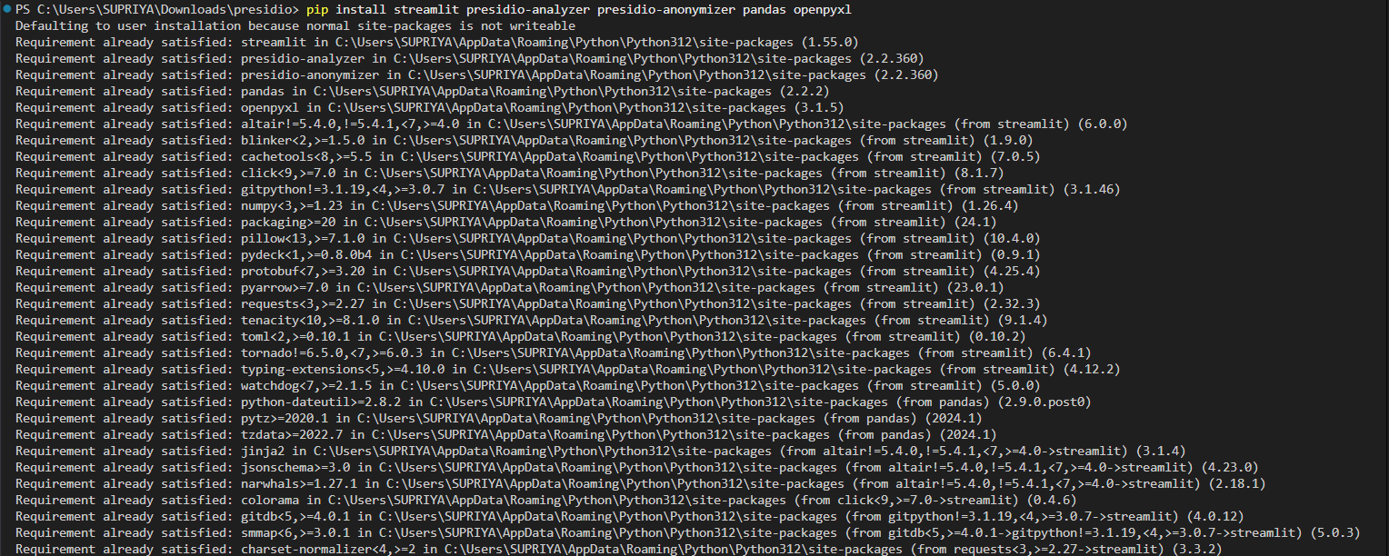
>streamlit run app.py
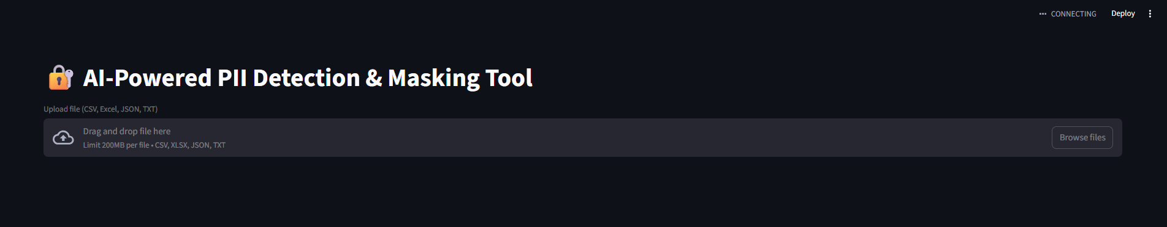
>Click the url and you will find the ui
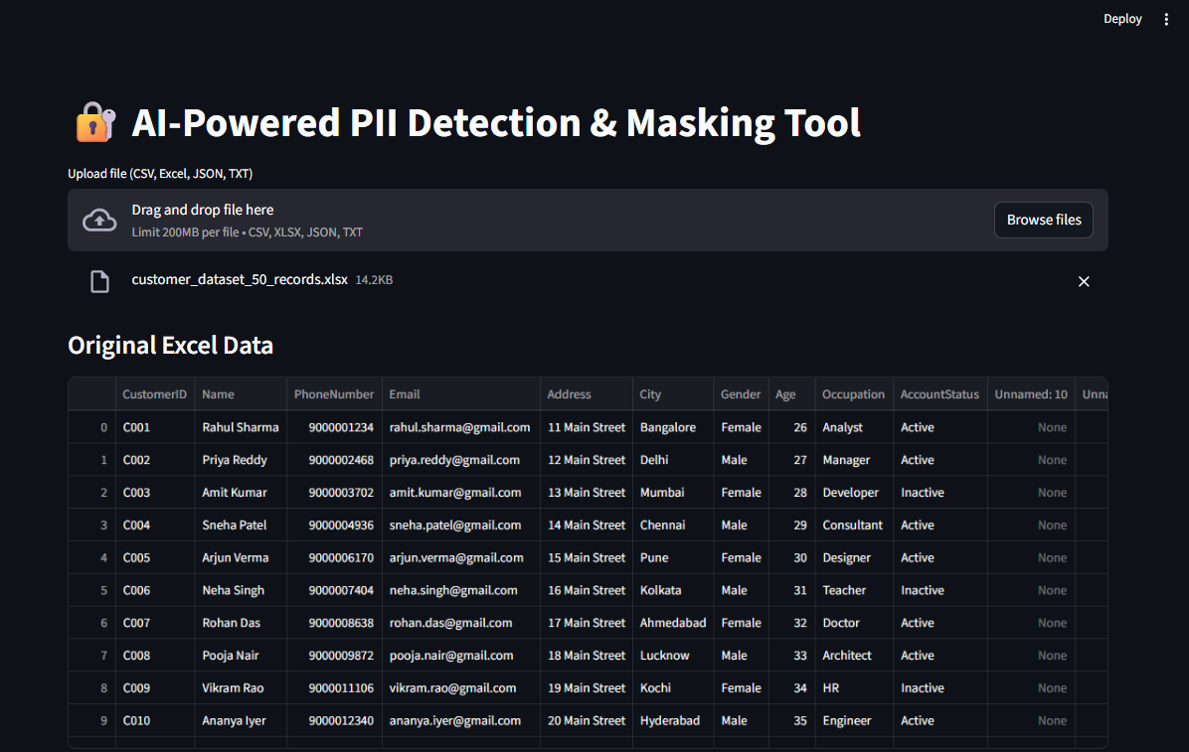
Step 7: Click on the Browse files and upload any file in format of Csv,txt,xls,JSON.
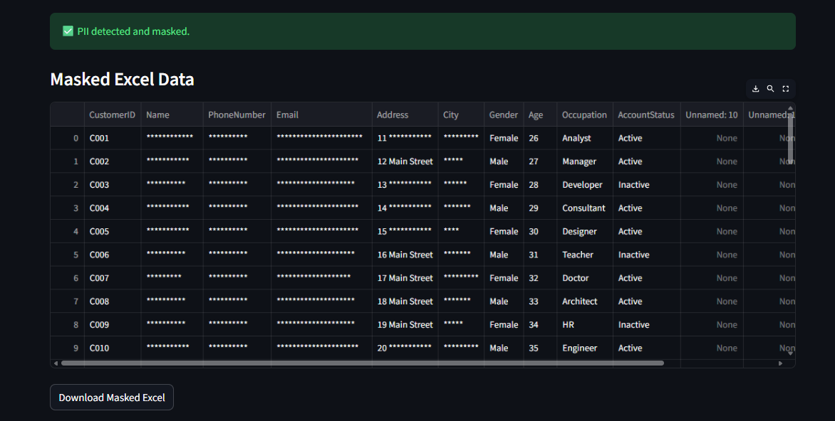
Output: you can view directly or you can download directly from there

